MagniSnap
Problem Definition 2
Terminologies 2
Project Requirements 4
Provided Implementation 4
Required Implementation 4
Input 4
Output 4
Test Cases 5
Deliverables 5
Implementation (60%) 5
Document (40%) 5
Allowed Codes 5
Milestones 5
Appendix: Template Code Description 6

Problem Definition
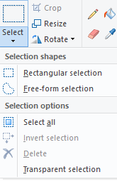
Selection tools (similar to the one in MS-Paint ex: fig1) can be used to select objects in an image to resize/delete/copy/move the objects. There are many types of selection tools such as rectangles or free-form selection tool, sometimes free-form selection tools are called Lasso’s. You can imagine a lasso as a rope surrounding your selection. Unfortunately, selection using ordinary lasso’s can be tedious and boring. In Photoshop, there is a more advanced version of ordinary lasso’s called Magnetic Lasso Tool. 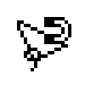 Magnetic Lasso Tool is a lasso that automatically snaps to the objects’ boundaries (ex: Figure 1). You can watch a demo of it here (local version is here).
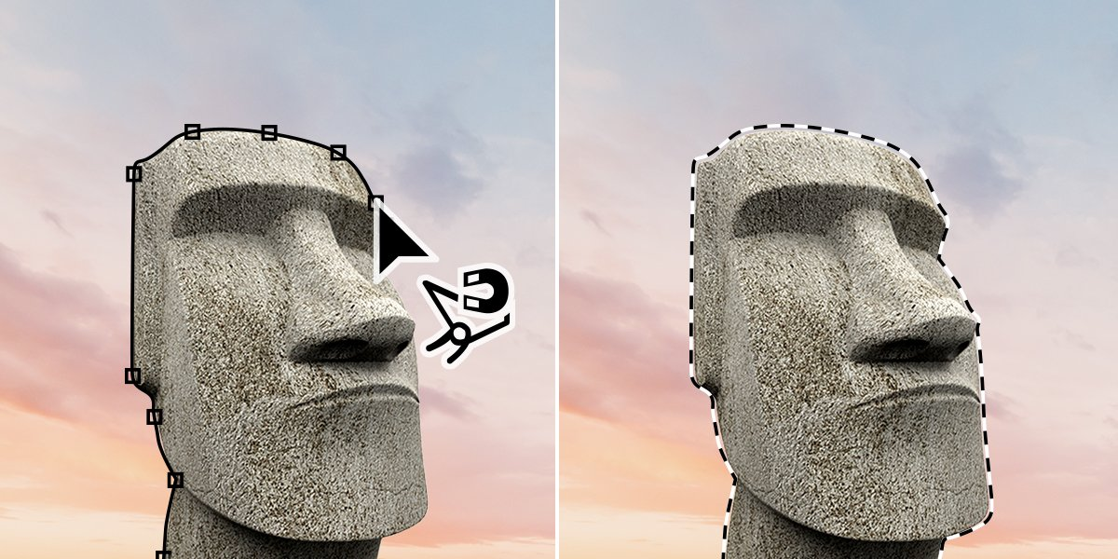
Figure 1 car selected using magnetic lasso tool
Fig1: selection in MS-Paint
The technical term for the Magnetic Lasso Tool is Livewire or MagniSnap. In this project we want to implement a simple magnetic lasso to learn more about image processing, graphs, and greedy algorithms.
Terminologies
- Livewire:
  - A livewire is defined by two points and a wire (path) between them:
    - Anchor point: a fixed point on the image the user selects at the beginning.
    - Free point: a moving point following the mouse cursor.
- Image:
  - 2D images are usually represented as a 2D array of pixels.
  - Each pixel may contain either one (for gray images) or three (for colored images) values (fig3.a). These values are often called Image intensity (I).
  - Image intensity at pixel(i,j) (I[i,j]) is the color of the image at that pixel.
  - Ex: in the rubik’s cube image shown (Fig3.a), it is a 512x512 RGB image, and each pixel contains three values to represent the color RGB (Red, Green, Blue).
- Converting colored image to grayscale:
  - Colored images can often be converted to grayscale by taking the average value of the image’s three channel’s (Red, Green, Blue) (fig3.b).

- Edge detection:
  - There many simple image filtering techniques (outside this course’s scope) that can detect the object boundaries (edges) and tell us the position and strength of an edge at a certain pixel (fig3.c).
  - An image-edge can be simply defined as a sudden change in image intensity at a certain position.
  - Since these edges represent the object’s boundary, we can use these edges to snap or pull the lasso towards them.
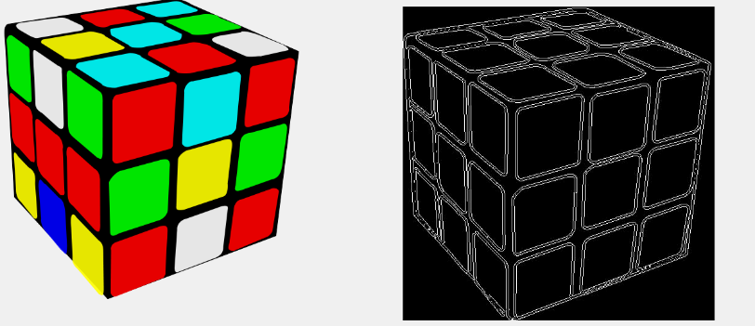
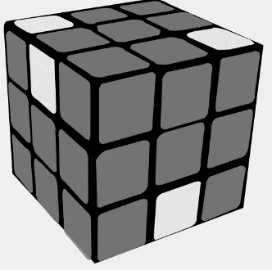
Fig3: a) colored image. b) gray-scale image. c) edge-image.

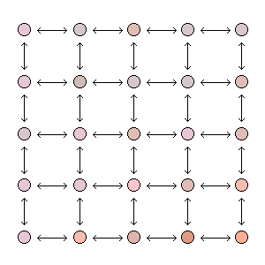
- Representing images by graphs:
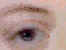
  - Images can be represented as graphs, which can be helpful in many image analysis problems, because it reduces the problem from an image domain problem to a graph domain problem. On such graphs you can apply typical graphs algorithms (Dijkstra, BFS, DFS, …etc) to solve the problem at hand.
- Graph construction:
  - To construct an undirected weighted-graph we need to define:
    - Vertices (nodes).
Fig4: image pixels represented as graph vertices (nodes), and the pixels’ neighborhood is represented as graph edges.
    - Connectivity (edges).
  - This image-graph can be structured as follows:
    - Vertices: Each image pixel is considered as a vertex in the graph. So if we have an NxM image then we have an NxM vertices in our graph.
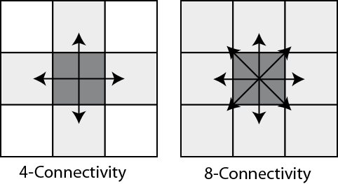
    - Connectivity: there are many ways to connect the vertices grid, the simplest way is to establish a 4-connectivity (fig5). So we need to connect each pixel with the pixel on the above, below, left, and right.
Fig5: connectivity types
- Mapping a “livewire in an image” problem to a “shortest path in a graph” problem:
  - Assuming that we have an undirected weighted-graph for the image, with small weights on the objects’ boundaries (image-edges) and large weights at the homogenous parts of the image.
  - If we need to generate a livewire between two pixels P1(i,j) and P2(x,y), it is the same as getting the shortest path between the two corresponding vertices V1(i,j) and V2(x,y), because the low edge-weights are at the image-edges on which we want our livewire to snap on.
  - Now remains one issue towards constructing our graph, which is determining the edges’ weights between pixels.
- Edge Weights Generation:
  - Assuming that you have a value G that measures the image-edge strength and direction between two pixels P1 and P2 (Since, calculating G is out of the course’s scope. You will be supplied with a function that calculates G between two given pixels).
  - Then we can set the edge-weight between P1 and P2 as W_{p1,p2} = 1/G. so regions with Low G have high weight, and regions with high G have low weight.

Project Requirements

Provided Implementation
- Template for opening and displaying the images.
- Function to calculate the edge-strength G between two pixels.
Refer to Appendix for more details.

Required Implementation
Requirement | Performance
- Construct an undirected weighted-graph for a given image. | Time: should be bounded by O(N²)  N: width/height of the image
- Calculate the shortest path EFFICIENTLY from an anchor pixel (vertex) to all pixels (vertices in the graph). | Time: should be bounded by O(E` lg(V`))  V`: # of vertices that are checked until reaching the destination  E`: # of edges that are checked until reaching the destination, E` = O(N²)
- Backtrack the shortest path from a free point (mouse position) to the anchor point. | Time: should be bounded by O(N)
- Draw the path on the image. | Time: should be bounded by O(N)
- [Bonus] Generate a sequence of connected paths using multiple anchor points. | Shortest path calculation: should be bounded by O(N² lg(N))  Shortest path drawing: should be bounded by O(N)

Input
- Image (2D array of pixels).
- Anchor point.
- Free point.

Output
- Path between the anchor and the free point.

Test Cases
- Sample Cases
- Complete Cases

Deliverables

Implementation (60%)
- Graph construction.
- Shortest path EFFICIENT implementation.
- Path backtracking and drawing.
- [Bonus] Support multiple anchor points.

Document (40%)
- Graph construction description and code.
- Used shortest path algorithm code.
- Detailed analysis of the above codes.

Allowed Codes
- Given template to:
  - Open and display the images.
  - Function to calculate the edge-strength G between two pixels.
Refer to Appendix for more details.
- No other external code is allowed.

Milestones
Deliverables
- Construct a weighted graph for an image
- EFFICIENT implementation of shortest path between start anchor point and free points.
- Backtrack the shortest path from a free point (mouse position) to the anchor point.
- Draw the path on the image from a free point (mouse position) to the anchor point
- [Bonus] Draw the path on the image by supporting multiple anchor points.
- Documentation
For Project Delivery :
  - MUST deliver the required tasks and ENSURE it’s worked correctly
  - MUST deliver in your scheduled time (TO BE ANNOUNCED)

Appendix: Template Code Description
C# Code contains ImageOperations class with the following functionalities:
- Open image & load it in a 2D array stored in a global variable of type MyColor [,]called ImageMatrix
MyColor [,] OpenImage(string ImagePath)
- Get width and height of the image matrix
int GetHeight(MyColor[,] ImageMatrix)
int GetWidth(MyColor[,] ImageMatrix)

- Calculate the energy between two pixels
double CalculatePixelsEnergy(MyColor Pixel1,MyColor Pixel2)
- Display an image on a given PictureBox control
void ViewImage(MyColor[,] ImageMatrix,PictureBox PicBox)

MyColor is a structure defined in the code to hold the Red, Green, Blue values of each pixel

